**Project Design Phase**

**Solution Architecture**

|  |  |
| --- | --- |
| Date | 27-08-25 |
| Team ID | LTVIP2025TMID61022 |
| Project Name | Book nest:where stories nestle |
| Maximum Marks | 4 Marks |

**Solution Architecture:**

**Solution architecture is a structured process that bridges the gap between the business problem of limited and costly book accessibility and a technology-driven solution. For Book Nest, it defines how the system will be designed and delivered to meet user needs effectively.**

**Its goals are to:  
● Find the best technology solution to provide users with an easy way to browse, order, and get books delivered.  
● Describe the structure, characteristics, behavior, and other aspects of the Book Nest platform to project stakeholders.  
● Define features, development phases, and solution requirements such as user login, book catalog, cart, and checkout process.  
● Provide specifications according to which the solution is designed, managed, and delivered, ensuring scalability, security, and user satisfaction.**

**Example - Solution Architecture Diagram:**

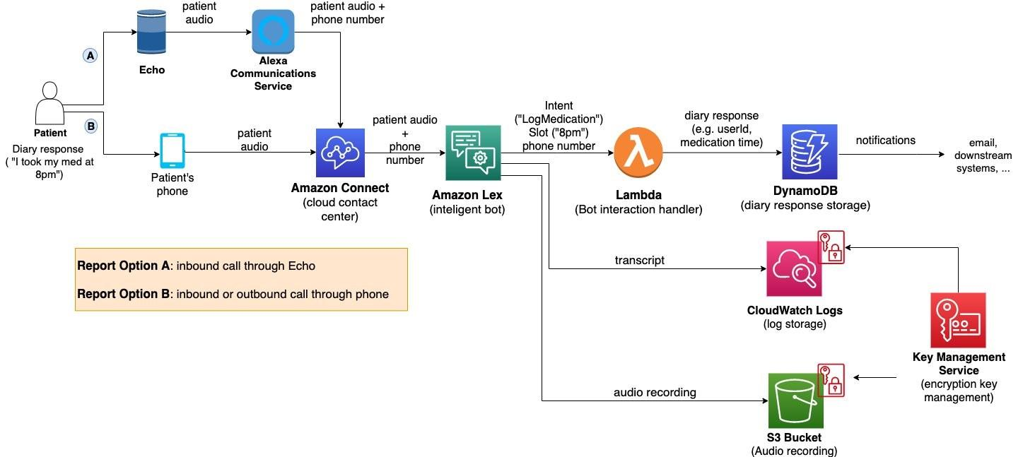

*Figure 1: Architecture and data flow of the voice patient diary sample application*

**Reference:** [**https://aws.amazon.com/blogs/industries/voice-applications-in-clinical-research-powered-by-ai-on-aws-part-1-architecture-and-design-considerations/**](https://aws.amazon.com/blogs/industries/voice-applications-in-clinical-research-powered-by-ai-on-aws-part-1-architecture-and-design-considerations/)